Task 3: CSS Selectors
CSS Selectors:
CSS selectors are patterns used to specify which HTML elements to style. They act as filters, allowing you to target specific elements based on their tags, classes, IDs, attributes, or other characteristics.
How CSS Selectors Work:
- Element Selector: Targets all elements of a specific type. For example, p selects all paragraph elements.
- Class Selector: Targets elements with a particular class attribute. For example, .my-class selects all elements with the class "my-class".
- ID Selector: Targets a single element with a unique ID attribute. For example, #my-id selects the element with the ID "my-id".
- Attribute Selector: Targets elements based on their attributes. For example, [href] selects all elements with an href attribute.
- Pseudo-class Selector: Targets elements in specific states or conditions. For example, :hover selects elements when the mouse hovers over them.
Example HTML Document:
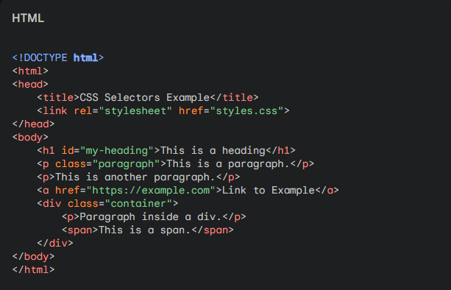
CSS Rules:
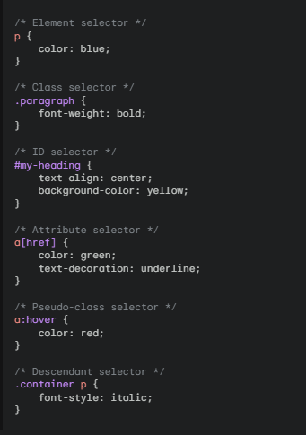
Explanation:
- The p selector styles all paragraph elements with blue text.
- The .paragraph selector styles paragraphs with the class "paragraph" with bold font weight.
- The #my-heading selector styles the heading with the ID "my-heading" with centered alignment and a yellow background.
- The a[href] selector styles all links with an href attribute with green text and an underline.
- The a:hover selector styles links when hovered over with red text.
- The .container p selector styles paragraphs inside the element with the class "container" with italic font style.
By understanding and using CSS selectors effectively, you can precisely target and style specific elements in your HTML documents.

